TOWN AND COUNTRY PLANNING (SCOTLAND) ACT 1997 (the 1997 Act)

SUBMISSION BY NOT COUL TO THE HIGHLAND COUNCIL AS TO WHY THE PLANNING AUTHORITY SHOULD DECLINE TO CONSIDER AN APPLICATION FOR PLANNING PERMISSION

for

Construction of an 18 hole golf course, practice area, access, parking, ancillary infrastructure and the change of use of existing buildings to form clubhouse, pro shop, maintenance shed and ancillary facilities on land 1700M NW Of Embo Community Centre School Street, Embo known as Coul Links

THC REFERENCE 23/00580/FUL

INTRODUCTION
This is a submission by Not Coul, a third party objector group opposed to the above application. The 1997 Act, by s. 39, authorises a planning authority to decline to determine an application, if, in the period of five years ending with the date on which the current application is received, the Scottish Ministers have refused a similar application referred to them. That is the case here.

An application for planning permission for an 18 hole golf course at Coul Links, Embo 17/04601/FUL was called in for a decision by Scottish Ministers. Following a four week public local inquiry it was refused by Ministers decision dated 21 February 2020 (NA-HLD-086).

SUBMISSION
The Planning Authority (The Highland Council) should decline to consider application 23/00580/FUL or show cause why, in the face of conﬂicting and up-to-date guidance, it is prepared to consider the application.

THREE STAGE PROCESS
The exercise of this power given by statute (the s. 39 power) is discretionary, not mandatory. There are three stages in the process to be undertaken.

First, the planning authority has to decide whether, as a matter of fact, the application is similar to an earlier, refused application. “Similar” means that the proposed development and the earlier development to which the applications relate are the same or substantially the same.

Secondly, it must decide whether, as a matter of discretion, it should decline to consider the application on the ground or grounds that it is similar to or substantially the same as the earlier application, determined within the previous five years on its own merits.
Discretion must be exercised rationally and fairly.

Thirdly, the Planning Authority must also assess whether there has been any signiﬁcant change in the Development Plan in the interim, or in any other material considerations since the previous decision.

“SIMILAR OR SUBSTANTIALLY THE SAME”
The ﬁrst task to be undertaken is to compare the salient features of the new application with the old.

Section 39A of the 1997 Act requires the SG to publish guidance outlining what constitutes “a similar application” and “a significant change” for the purposes of an application to a local authority to decline to consider a second application. There was earlier guidance in Circular 22/1991, but that has been repealed. Current guidance is reported below. Section 39A was inserted on 1 October 2022, which was the commencement date for ss. 22 and 38 of the 2019 Act (see SSI 2022/275).

There is only one reported case, namely Noble Organisation v Falkirk DC 1993 SC 221 and 1994 SLT 100. It refers to the old Circular, but was decided on the basis that the local authority had not left anything material out of account in reaching its decision i.e. traditional judicial review grounds. It is useful as far as it goes, but it takes this case no further.

CURRENT GUIDANCE
Following commencement of ss. 22 and 38 of the Planning (Scotland Act) 2019, current official Guidance is to be found in Circular 3/2022, Annex E. That is annexed below, in Appendix 1. It suggests the following questions

QUESTION 1
Are the development and the land to which the applications refer the same or substantially the same?

ANSWER 1
- The type of development proposed by both applications is a golf course, consisting of eighteen holes laid out across Coul Links. By reference to the accompanying map (appendix 2 below) it can be seen that the layout of the proposal is similar, if not precisely congruent with the first application. The applicant’s Planning Statement implies at paras 1.1 and 2.1 that a par 3 course forms part of the application. But it is not mentioned on the application form. Which is the legally definitive statement?

- The scale of the proposed development is virtually identical to the first application refused in 2020.

- The nature and scale of any mitigation proposed as part of the development; and

- The site boundaries of the proposed development are practically identical.

The applicant has laid out as a table in the Planning Statement at page 45 a “Course Comparison”. By adding an additional column, and showing its observations in red, Not Coul demonstrates here that for the reasons shown there, this proposal is as close in shape, location, nature and effect as the first application as makes no difference. That document is attached below as Appendix 3.

In such an important triple designated¹ location, comparisons of this kind can easily be made. Section 39 is not designed to require a detailed forensic dissection of original and succeeding applications. It uses the terms “similar” and “substantially the same” because it intends the reader to take a strategic, relatively high level approach, focussing on salient, indicative characteristics. This application is as close as it can be to the first application without being precisely congruent with it.

In such circumstances, it is submitted that the outcome of an application for planning permission is predictable. So great are the many offences against Nature and infringements of the natural order; so severe would be the likely damage to Nature itself in the many forms in which is appears on this site that refusal is the only sensible outcome. Mitigation is simply impossible, and such mitigation as is proposed now is similar to, or substantially the same as, that proposed for the first application. If the application is not refused the interests which are already so closely protected at Coul Links cannot remain protected, as the land designations indicate is required. A significant thrust of the Planning Statement (e.g. paras 2.7, 2.10, 4.4, and 4.7) is that there is to be mitigation, as was advanced in the first application.

QUESTION 2

The second task is to ascertain how discretion should be exercised.

ANSWER 2
The exercise of discretion is a matter of professional judgment, but judgments must be made on fair and rational grounds. The purpose of s. 39 must be considered; it is clearly to deter repeat applications which may be designed to intimidate or wear down a planning authority. On the other hand, every applicant must be allowed to fairly present its application and to have it considered.

However, if an application falls within the parameters of s. 39, as the current application does, then absent any saving material consideration the inherent presumption is that it will be declined for consideration. On this matter both s. 39 and the Guidance are explicit. Fairness is bilateral; the s.39 decision must be fair to an applicant, so that it understands why its application cannot be considered further, and it must also be fair to those having an interest in the outcome of the application, including members of the public.

A decision maker faced with a s. 39 application, such as this one, given a finding of “similar or substantially the same” in answer to the first question (above) must weigh up the competing arguments, and reach a rational and intelligible decision, always having regard to the purpose of the section, which is clearly restrictive and not permissive. The decision maker must be able to give reasons for his/her decision.

It was clearly the intention of Parliament to save public money and the burdens upon local authority planners by restraining repeat applications where they are similar in kind and character to those presented at an earlier time. Where applications are indeed “similar or substantially the same” the onus to show that the application should be considered lies firmly with the applicant. In this case, the Applicant has not addressed s.39, yet newspaper report shows that THC drew the local authority Councillor’s attention to the matter at screening stage. ² It is reasonable to expect that the author of the Planning Statement would be aware of the commencement of s. 22 of the 2019 Act.

Where the language of a section is discretionary the scope of the discretion may only extend to taking one of the specified courses – either to decide to consider the application, or to decide not to do so. No additional option or options is/are admissible. There is no generic policy indicating what should or should not be done across the board with such applications. Each application must be considered on its individual merits.

1 Site of Special Scientific Interest; Special Protection Area; and Ramsar site.
2 See www.northern-times.co.uk/news/two-year-obstacle-to-coul-links-plan-215720/

In this case, it is clearly submitted that the LPA should have regard to the fact that the present application discloses substantially the same planning considerations as the first application. These include the fact that prima facie both applications are contrary to the Local Development Plan and landscape designations; that they are in the same location, more or less exactly; and that the same rules apply. In the circumstances, the proper exercise of discretion, taking all relevant matters into account, is for the Local Planning Authority to refuse to consider this application until five years have elapsed.

QUESTION 3

The third task is to ascertain whether the Development Plan has changed?

ANSWER 3
It has changed, yet it has also not changed. The Caithness and Sutherland LDP (CaSPlan) was adopted in August 2018. But it stipulates that it must be read with the Highland Wide Local Development Plan of 2012, which was in place and governed the decision at the time of the first application. The CaS Plan has no site specific policies relevant to Coul Links, but it does contain a series of general policies governing employment, tourism and the environment. All of these “new” policies are derived from the HWLDP 2012. There is no substantive difference, which is the s.39 test in the Circular. Moreover, additional Supplementary Planning Guidance relied on in this application was in existence at the time of the first application, and is now apparently relied on once again. In other words, the rules are the same.

In addition, as a matter of law National Planning Framework 4 has now been adopted into all local development plans on 13 February 2023. A complete summary of CaS Plan and NPF 4 is beyond the scope of this submission, but the references to sustainability, climate change and the biodiversity crisis in the HWLDP are all reinforced by NPF 4, and are similar to and cognate with the planning criteria applied to the decision in the original application. In other words, policy considerations are the same as they were in 2020. Reference is made to the Circular, Annex E, specifically the fifth bullet at para 7, and para
- The governing policies are not substantially different now than they were in 2017, and those material to this application are essentially unchanged.

The changes in the LDP overall since the first application do not make this a “different” application; the facts of the two applications are all but identical, and the rules which now apply to the assessment of those facts are the same in character.

SUMMARY AND CONCLUSIONS

  - The facts do not lie. The two applications are as close to each other on the ground and in relation to the subject land as makes no difference. The nature, extent and character of what is proposed is similar to or substantially the same as the application rejected by Scottish Ministers.

  - The fair exercise of discretion would recognise the similarities and coincidence between the two applications and apply s. 39 to the current application.

  - There have been no material changes to the Local Development Plan which alter the framework of rules which are to be applied to this application, thus changing the context in which it is to be considered. The plan led framework is the same now as it was in 2020.

For these reasons, THC is respectfully asked to make a clear ruling under s. 39 of the 1997 Act, and to refuse to consider this application.

Fairness requires that the applicant be given time to consider and respond to this application for the operation of s.39. It is therefore submitted that the time for comment upon the application as a whole by the public should be extended by at least 28 days to allow for that response.

RESPECTFULLY SUBMITTED

JDCKC For Not Coul March 2023
Appendices
Appendix 1 Annex E, Circular 3/2022
Appendix 2 The applicant’s map of the subject land. Appendix 3 Course Comparison table

APPENDIX 1

ANNEX E, CIRCULAR 3/2022

Declining to Determine Planning Applications Repeat Applications
- Section 39(1) contains discretionary powers for planning authorities to decline to determine repeat planning applications. Where the Scottish Ministers
have, within the previous 5 years, refused permission on a similar application on call-in or appeal and, in the opinion of the planning authority, there has been no significant change in the relevant parts of the development plan or other material considerations since that decision, the planning authority can refuse to deal with the application.

- The same discretionary power applies where more than one similar application has been refused in the previous 5 years and no appeal has been made or has been made but not determined. In these cases the above criterion relating to changes in the development plan or other material considerations relates to the period since the most recent refusal of a similar application.

- The discretionary powers to decline to determine a repeat application also apply where an application is subject to a right to local review by the planning authority rather than a right to appeal to the Scottish Ministers. For example, where a similar application has been refused on local review within the previous 5 years and there is no change in the development plan or other material considerations, then the planning authority may decline to determine the application.

- Section 39(2) outlines what constitutes a similar application for the purposes of planning authorities' power to decline to determine applications for planning permission. It states that applications are only to be taken as similar if the development and the land to which the applications relate are - in the opinion of the authority - the same or substantially the same.

- Whether the development and land to which the applications relate are the same (i.e. identical) will be a matter of fact. However, whether the development and land to which the applications relate are "substantially the same" will depend upon the degree to which they differ from the proposals for which planning permission was sought by the earlier application. As section 39(2) states, this is a matter of judgement for the authority.

- The planning authority's opinion on this will be dependent on the specific circumstances of the case, the particulars of the proposed development and its planning context. In exercising this judgement, authorities will wish to consider the extent to which there has been a change in:

  - The type of development proposed;
  - The scale of the proposed development;
  - The design and layout of the proposed development;
  - The nature and scale of any mitigation proposed as part of the development; and
  - The site boundaries of the proposed development
- Whether there has been a "significant change" in the development plan which is material to the current application, or a significant change in any other material consideration, will also depend on the circumstances of the particular case and is also a matter of judgement for the planning authority. Relevant considerations will include:

  - The reasons why a similar application was refused and the policies and/or considerations on which that decision was based;
  - Any relevant planning decisions (including appeal or local review decisions) taken in the intervening period;
  - Whether, during the intervening period, any new national or local plans, policies, proposals or provisions have been published;
  - Whether such plans, policies, proposals or provisions were published in draft or finalised – and whether they have any relevance to the current application;
  - Whether such plans, policies, proposals or provisions are substantively different from any equivalents that were applicable when a similar application was refused; and
  - Whether, during the intervening period, any other developments have been approved, completed or are under construction which affect the planning context or setting of the site (e.g. the provision of new or upgraded infrastructure that is relevant to the proposed development).
- In general terms, there is likely to have been a significant change where part of the development plan has been updated or amended (for example, the adoption of a new local development plan or the NPF becoming part of the statutory development plan) unless the provisions of the development plan which are material to the particular case are essentially unchanged.

- These are discretionary powers. A planning authority is not obliged to decline to determine an application even if, in the opinion of the authority, it constitutes a similar application and there has been no significant change in the development plan or material considerations, and all other relevant criteria have been met.

Applications without the necessary pre-application consultation (PAC)

- Section 39(1A) requires that planning authorities decline to determine a planning application to which the PAC requirements apply and where the applicant has not complied with those requirements.

- The planning authority may, before declining to determine an application in these circumstances, ask the applicant to provide such additional information as they may specify. There is therefore some discretion for the planning authority to request additional information to demonstrate that the requirements have been complied with or that some previously missing aspect of required PAC had subsequently been undertaken.

- When declining to determine an application in these circumstances, the planning authority must advise the applicant of the reasons for its opinion that the applicant has not complied with the PAC requirements. The requirement to decline to determine due to an absence of required PACdoes not apply where the applicant has:

  - a statement of the planning authority's opinion under section 35A(3) to the effect that the proposal is not in a class of development which requires PAC; and
  - submitted the related application within 12 months after submitting the notice seeking the planning authority's opinion, and the proposal does not differ materially from the information provided in that notice.
Or

  - an exemption from PAC applies under section 35A(1A)(a) or (b).

- See paragraphs 1 to 3 in Annex B on PAC exemptions. Where an applicant is intending to rely on an exemption from PAC under section 35A(1A)(b), they are to include a statement to that effect with their application (Regulation 4A(3).

No Right to an Appeal to Scottish Ministers or Local Review where a Planning Authority Declines to Determine and Application

- Where a planning authority declines to determine an application under section 39, the applicant does not have a right to an appeal or a local review on the grounds of non-determination (Sections 43A(8A) and 47(2)). As no decision has been made to either refuse planning permission or grant it with conditions, then no right to appeal or seek local review of such decisions under sections 43A and 47 applies.

APPENDIX 2 THE APPLICANTS PLAN
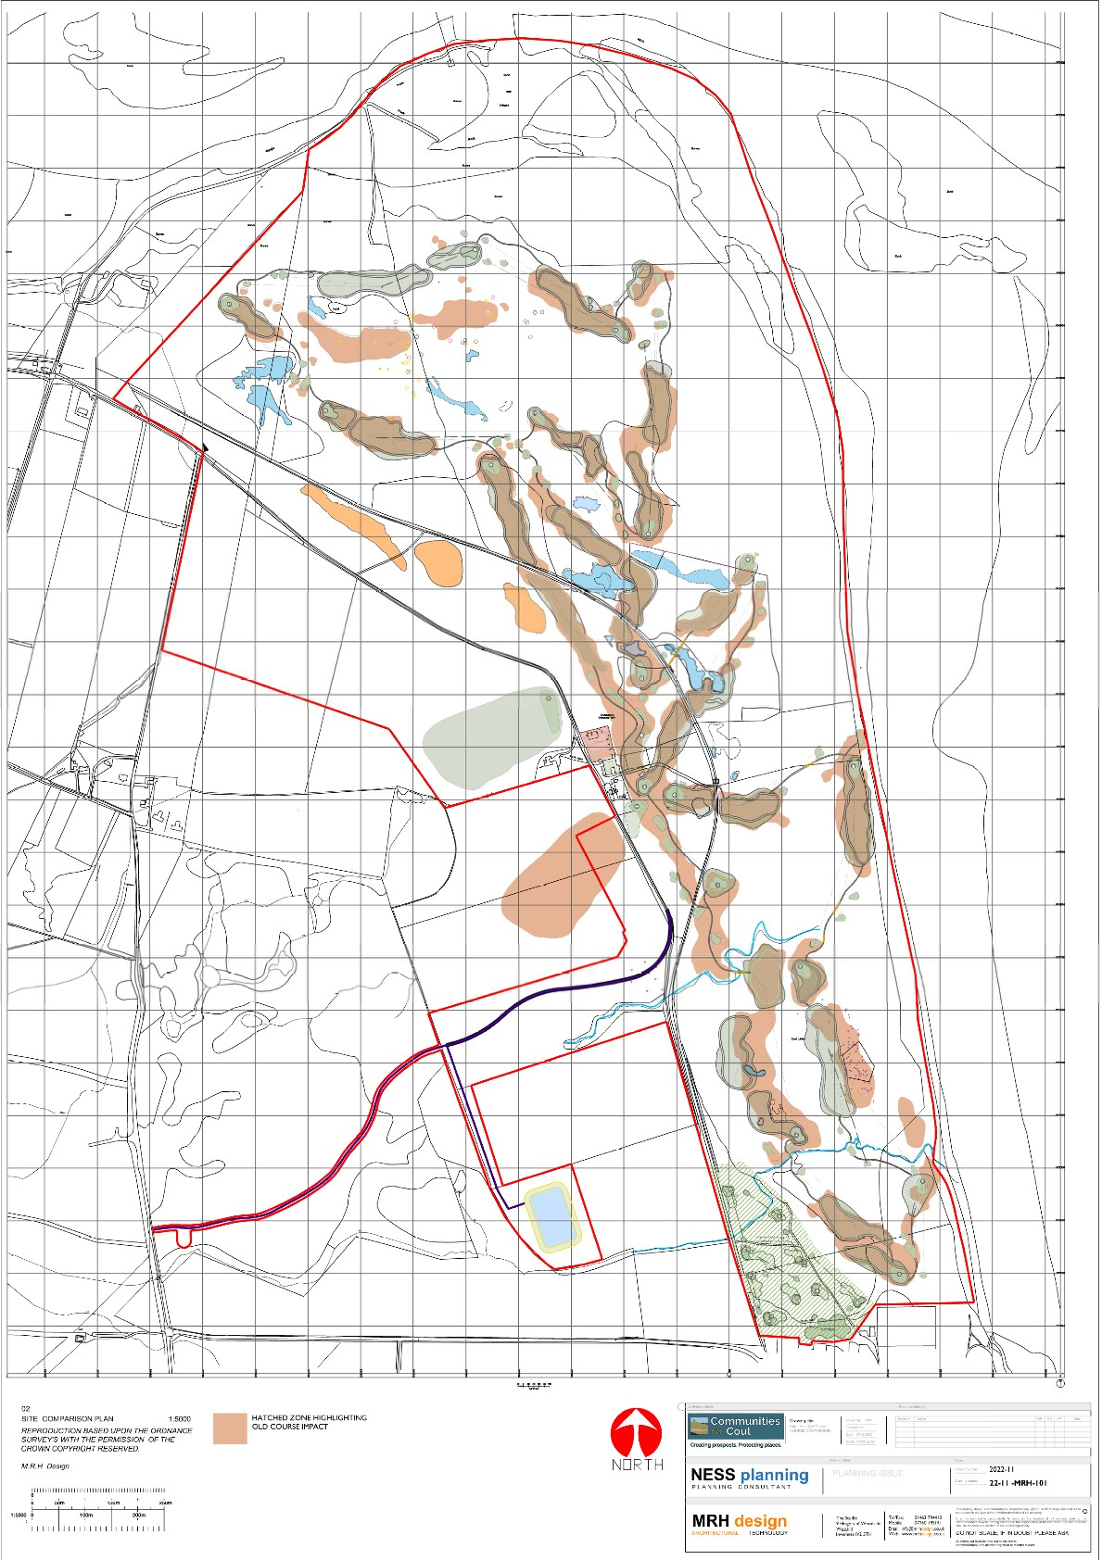

APPENDIX 3
COURSE COMPARISON adopted from pp. 45-46 of the Planning Statement

Table 1 Topic | Proposed Course Layout | Original Course Layout | Percentage change | Similar or ‘substantially the same’
Site boundary | 317.7 hectares | 328 hectares | 3.2% reduction In area | Immaterial difference, so substantially the same
Course developed total  site area | 22.7 hectares (including  roughs) | 22.7 hectares  (excluding roughs) | n/a | Similar
Area developed within SSSI involving stripped vegetation (direct impact) | Direct impact in SSSI is 1.5 ha | 14.7 hectares of impact in SSS | 90% reduction in the area developed or altered (direct impact) within the SSSI | It is impossible to use mowing to produce fairways without adverse direct impact. Fairway area has to be added to 1.5 ha. That outcome will be similar.
Areas of new grass seeding in SSSI | 1.5 hectares | 14.7 hectares | 90% reduction in intervention and new seeding | ditto
Ground stripping in SSSI | 1.5 hectares | 14.7 hectares | 90% reduction | As above, mown fairways have the same adverse effect as conventional fairways on biodiversity receptors.  Fairway extent needs to be added to 1.5 hectares. The  outcome is similar.
Overall direct impact in SSSI | 1.5 hectares | 14.7 hectares | 90% reduction | The same; fairway extent needs to be added to 1.5ha. The SSSI boundary is intended to be constant (or extendable, e.g. as a condition in the 2019 Inquiry  planning conditions).
Outside SSSI direct impact | 1.7 hectares | 8.0 hectares | 79% reduction | The fairway extent of Holes 14 and 15 need to be added to 1.7 hectares. There is no mention of the 14-hole par 3 course. That is outside the SSSI. Including that might increase the scale of negative impact. The outcome of direct impact adjustment is either similar or worse.
Fertiliser use | Applied to tees and greens only | Previous use involved fairways, tees greens and paths | 85% reduction | Mowing Coul dune heath and dune grassland will not produce world-class playing surfaces. The course operators will have to replace poor fairways with conventional fairway construction. Those replaced fairways will require fertiliser.
 |  |  |  | The outcome will be similar, not 85% reduction.

Table 1 Topic | Proposed Course Layout | Original Course Layout | Percentage change | Similar or ‘substantially the same’
 |  |  |  | Climate change studies suggest that the world, including this part of Scotland, is moving towards more frequent and longer droughts. NatureScot work in 2022 presents this forecast with evidence.
Irrigation requirement | Required for tees and greens only  10000m3 annually during grow-in  5000m3 annually during operation | Required for tees greens and all new seeded areas.  30000m3 during grow- in  15000m3 during operation | 80% reduction in irrigation of golf course | The course fairways will need watering, in the unlikely event that they can be established in the first case, just as the first proposal’s fairways did. Dune heath has little or no grass as a response to mowing, only moss. Many dune grasslands have bunch grasses, not sod formers. At some stage the course will need to switch to installing conventional fairway grass species. They will need more irrigation.
 |  |  |  | Net result is similar.
Width of paths | 1.5-1.8 metres | 5 metres with excavation of ground and seeding required | 70% reduction in  width 100% reduction in intervention and adjusted ground levels | Similar adverse eﬀects on biodiversity because path width is only one factor is impact assessment.
Wildlife corridors for connectivity | Fairways designed with connectivity and broken up into sections to avoid fragmentation | Fairways designed with obvious connectivity and broken up into sections to avoid  fragmentation | Extended fairways continuous[ly?] acting as potential barriers | Marginal diﬀerence to scale of adverse fairway impact on invertebrates in particular.  Net result is similar.
Construction traffic | Reduced requirement for HGV traffic, generally limited to construction of the new access road, drainage and conversion of existing buildings | Construction traffic required for the golf course, ground stripping and imported material and removal of stripped vegetation | 28% reduction due to the establishment methodology | The deforested enclosure will require removal of much timber brash, trunks and stumps.  It will require much larger construction machinery and extended time to construct here - several holes are routed here. Net result will be similar.
Edge eﬀect on fairways and paths | Edge eﬀect avoided and connectivity corridors created across mown areas including fairways and paths with reduced lengths of fairways and breaches between to preserve access across the site. Width reduction on paths to 1.8 metres limits fragmentation. Angled mowing provides a graded edge avoiding the barrier of a sharp boundary between mown and unmown vegetation. | All paths created and seeded with grass and mown. Paths up to 5 metres wide in places. Fairways soil stripped and sown with grass seed and mown and mown in part creating unnatural edges.  Roughs had unnatural stepped edges.  Fairways were extensive and acted as barriers to the movement of species. Detrimental to habitats and viability of the SSSI  designations | 100% reduction in edge eﬀect throughout the course profile. | The microclimate diﬀerence either side of angle-mown habitats will remain a significant barrier to an unknown proportion of the Coul invertebrate population.  The changes will adversely alter the distribution and movement of insects in particular, e.g. altering gene ﬂow.  These are many unknowns and the Precautionary Principle should be applied. The result for key receptors is similar.

[END]

